**The Fair Finance Guide Methodology**Overview of the methodology and research process

**Introduction**

* The [Fair Finance Guide](https://fairfinanceguide.org/media/498182/ffgi-policy-assessment-methodology-2023-ffi_final.pdf) Methodology (FFGM) is a comprehensive tool for assessing and comparing the Environmental, Social and Governance (ESG) policies of financial institutions. It is based on international sustainability standards and UN Conventions and is used as a tool to compare the sustainability and ESG policies of Financial Institutions (FIs).
* Developed by our network of policy research experts, Profundo and other stakeholders, the methodology is used to assess FIs' approach to sustainability across up to 19 themes.
* The methodology is a tool for benchmarking FIs’ ESG policies, tracking progress and helping to trigger a race to the top. The data also forms the basis for a constructive, evidence-based dialogue on more responsible and sustainable financial policies and practices.

**Content of the FFGM**

* The policies of FIs are assessed under different themes, which are divided into 9 cross-cutting themes, 6 sector themes and 4 operational themes. Each theme is introduced with an overview of what is at stake, the most important international standards and initiatives, and finally lists a set of key principles extracted from these international norms that are used as assessment elements to score the policies of FIs.

Table 1. Overview themes in FFGM

|  |  |  |
| --- | --- | --- |
| **Cross Cutting Themes** | **Sector Themes** | **Operational Themes** |
| Animal welfare | Arms | Financial Consumer protection |
| Climate Change | Food and agriculture | Financial inclusion |
| Corruption | Forestry | Remuneration |
| Gender Equality | Mining | Transparency and Accountability |
| Health | Oil and gas |  |
| Human Rights | Power generation |  |
| Labor Rights |  |  |
| Biodiversity |  |  |
| Tax |  |  |

* Out of the 19 available themes, 8 themes are core themes: Climate Change; Corruption; Human Rights; Labor rights; Biodiversity; Tax; Transparency and Accountability; and Gender Equality. The other 11 themes are optional for each Fair Finance coalition to include in their policy assessments depending on capacity and interest.
* The methodology is updated every one to two years to remain up to date with the latest international standards and to incorporate new data from across our global network. The current methodology refers to over 422 international standards and criteria and is the 8th update since the first international methodology was developed in 2014.
* The FFG methodology takes into account publicly available information only

**Dimensions**

* The FFG Methodology assesses FIs’ policies along 3 dimensions
  + Theme: sustainability issue or sector (see 21 themes above)
  + Content: level of adherence to international standards evaluated in specific *’assessment elements’*
  + Scope: the extent to which the policy is applied to all relevant types of investments and financial services in which a FI is active
* **Assessment elements**
* Based on international standards, initiatives and best practices, the assessment elements are the sustainability principles that FFI expects to see in FIs' policies.
* The majority of the elements apply to the financial activity level, i.e., the requirements and expectations on the companies that FIs’ invest in or finance (see for example elements 3 - 6 in the table below).
* Some elements apply to FIs’ internal operations (including their employees), see for instance element 1 and 2 in the below table

Table 2 Example of a number of elements in Human Rights theme

|  |  |
| --- | --- |
| *Elements relating to* ***bank operations****:* | |
| 1 | The financial institution respects all human rights as described in the United Nations Guiding Principles on Business and Human Rights. |
| 2 | The financial institution has a zero-tolerance policy towards all forms of discrimination in employment and occupation, including on the basis of gender, race, ethnicity, sexuality, and physical ability. |
| *Elements relating to companies* ***the FI invests in or finances****:* | |
| 3 | Companies respect all human rights as described in the United Nations Guiding Principles on Business and Human Rights. |
| 4 | Companies have a policy commitment to meet their responsibility to respect human rights. |
| 5 | Companies have a human rights due diligence process to identify, prevent, mitigate and account for how they address their impact on human rights. |
| 6 | Companies have processes to enable the remediation of any adverse human rights impact which they cause or to which they contribute. |

**Scoring**

* A score is assigned for each assessment element.
  + A full score (1) is granted if the FI’s policy commits to the sustainability principle and applies it to the full scope of financial activities.
  + A partial score (0,5 < 1) is granted if the policy has a limited scope.
  + A basic score (0,5) is granted if the policy fulfils essential parts of the principle but not fully.
* The element scores in a theme are then aggregated into a total theme score that is expressed as percentage or a scale of 0-10.
* A FI’s total score is then calculated as the average score of all assessed themes and presented as the top-level result, (see illustration below).

Table 3: Total score per FI in FF Germany’s policy assessment 2023

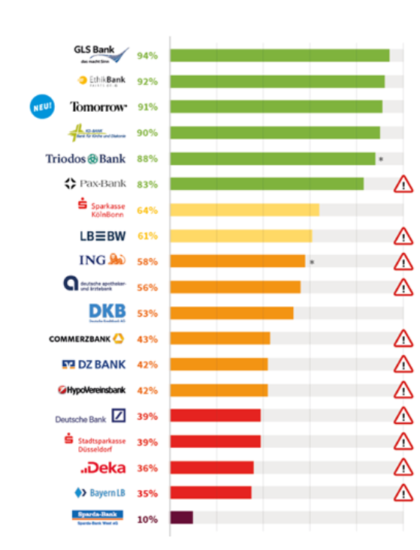

**Case studies to check the FIs’ practices**

* Next to the policy assessments, key work by the FFI Network is the publication of case studies. In case studies the operational practices, strategies and instruments of FIs are investigated more in-depth and the investments and financial services of the researched financial institutions are evaluated. Examples of case studies are
  + a [Fair Finance International report](https://fairfinanceguide.org/ff-international/case-studies/2022/fair-finance-international-report-on-financing-of-construction-and-hospitality-companies-in-qatar/) on financing of construction and hospitality companies and poor labour conditions in Qatar around the 2022 World Cup,
  + a [case study](https://fairfinanceguide.org/ff-international/case-studies/2022/stranded-assets-risk-in-the-context-of-climate-change-a-case-study-by-fair-finance-vietnam/) by Fair Finance Vietnam about stranded assets risk in the context of climate change -
  + a [case study](https://fairfinanceguide.org/ff-international/case-studies/2022/dutch-insurers-investing-13-billion-in-exotic-leather-and-fur/) by Fair Finance Netherlands on Dutch insurers investing 1.3 billion in exotic leather and fur,
  + a [case study](https://fairfinanceguide.org/ff-international/case-studies/2022/swedish-banks-increase-support-for-oil-companies-in-the-arctic/) by Fair Finance Sweden on Swedish banks increased financing of oil companies in the Arctic,
  + a [case study](https://fairfinanceguide.org/ff-international/case-studies/2022/fair-finance-brazil-one-in-five-consumers-complaints-left-unresolved-by-banks/) by Fair Finance Brazil which revealed that one in five consumers complaints are left unresolved by banks.
  + A [case study](https://cer.org.za/wp-content/uploads/2021/07/CER-FFCase-Study-Final.pdf) by Fair Finance Southern Africa which considers whether a key development bank is a responsible investor.
* The outcomes of these studies are reported on the websites of the different Fair Finance coalitions and the FFI [website.](https://fairfinanceguide.org/ff-international/case-studies/?p=2)
* The results of the case studies do not affect the policy assessments, and do not lead to a downgrade or upgrade of the policy assessment scores.
* In some coalition countries, the case studies are presented as a compliance check mechanism in relation to their policy scores. If a case study concludes that a FI has failed to act in line with its policy commitments, a warning sign is posted next to the FI’s policy score on the website, (see illustration below).

Table 5: FF Sweden’s policy ranking 2022 where many banks have warning signs. Case studies give additional information about certain financing and investment practices.

